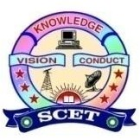

Event no: IV
Title of the Activity: Startup Competition
Organizing Unit
Entrepreneurship Development Cell (EDC)
(Under AICTE IDEA Lab Activities)
Date & Venue
- Date: 12-08-2025
- Venue: Decennial Block Seminar Hall
- Time: 09:00 AM onwards
Objective of the Activity
The objective of the Startup Competition was to promote innovation, design thinking, and entrepreneurship among students by encouraging them to transform innovative ideas and prototypes developed using AICTE IDEA Lab facilities into viable startup concepts. The activity aimed to strengthen the innovation-to-startup ecosystem within the institution.
Details of the Resource Person / Chief Guest
Sri Bandi Suresh
Former Vice President – Operations, Elitech Appliances
The Chief Guest delivered an expert talk on industry expectations, startup challenges, product development, and scaling innovations into sustainable business models.
Participation Details
- Number of Participants: 120 students
- Number of Teams / Ideas Presented: 20 Teams
- Departments Involved: EEE, ECE, CSE, IT, Mechanical, etc.
Description of the Activity
Student teams presented innovative startup ideas focusing on technology-based solutions, societal needs, and market relevance. Many ideas were conceptualized and refined through hands-on experimentation, prototyping, and design thinking practices encouraged under the AICTE IDEA Lab. An expert panel evaluated the ideas based on innovation, feasibility, and commercial potential.
Role of AICTE IDEA Lab
- Provided an ecosystem for hands-on innovation and ideation
- Supported prototype-oriented learning
- Encouraged interdisciplinary collaboration
- Enabled students to align technical skills with entrepreneurial outcomes
Outcomes of the Activity
- Enhanced awareness of startup culture and entrepreneurship
- Identification of potential startup ideas for further incubation
- Improved student confidence and presentation skills
- Increased utilization of AICTE IDEA Lab infrastructure
- Motivation for students to pursue incubation, MSME linkage, and startup registration
Impact
The activity significantly contributed to developing an innovation-driven and entrepreneurial mindset among students and reinforced the role of the AICTE IDEA Lab as a catalyst for skill development, creativity, and startup generation.
Conclusion
The Startup Competition successfully met the objectives of the AICTE IDEA Lab Scheme by fostering innovation, experiential learning, and entrepreneurship. Such activities strengthen the institutional startup ecosystem and prepare students to become future innovators and entrepreneurs.
Gallery
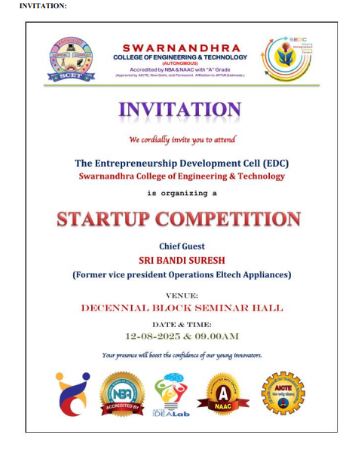 | 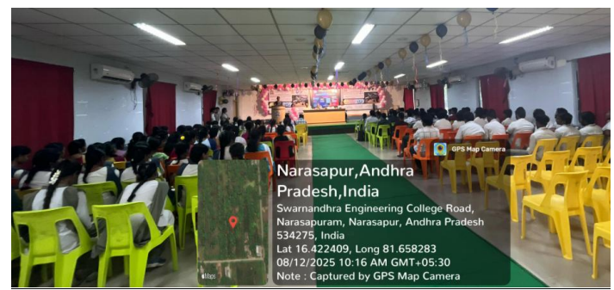
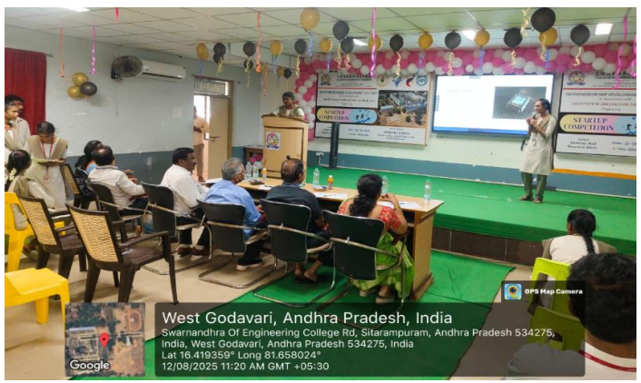 | 